DD Design Assignment **Automating Chess Board**

short line

Vidit Patel - 2018B3A70733G

Prabodh Kant Rai - 2018B3A70748G

Viraj V Aute - 2018B3A70741G

Aaryaman Gupta - 2018B3A70727G

Lakshay Dua - 2018B3A70735G

Ujjal Sharma - 2018B3A70742G

Shivansh Gahlot - 2018B3A70736G

**Question**

Design an automated chessboard where the user selects the chess piece and inputs the final position. Based on user input design a system that moves the chess pieces. Assume that your chess board is only automated for the queen and rook only. Assume that these pieces are automated by servo motors that move one box at a time in any direction.

# **Introduction**

The Chess board is mapped as a 2 dimensional graph with bottom left corner as origin and the top right corner as (7,7). The current location of each piece is already stored in circuit , so to start the simulation the circuit must be initialized by

* setting the input values equal to the JK Flip-Flops for both X and Y coordinates of each piece for initializing the piece to a specific location.
* Use the Reset Button to initialize the piece at (0,0)

Currently we are using the same circuit for both the pieces so the current location of the piece is lost if we change the piece from Rook to queen , So while implementing on hardware we could reuse the circuit and automate both rook and queen individually and not lose the current location of the piece.

**Design** **Assumptions**

* The board contains only one piece on the board.
* In case of an invalid move the piece would not move.
* After giving the input the players would wait till the circuit reaches a stable state, i.e. the piece reaches the final location. The player does not change the input in the middle of the move.
* In case the piece is changed after moving to a location , say (4,6) , the next piece would start from the current location as the previous piece ,i.e. (4,6). The location of the piece can also be initialized to (0,0) by using the reset button.

**Top Level Diagram**

[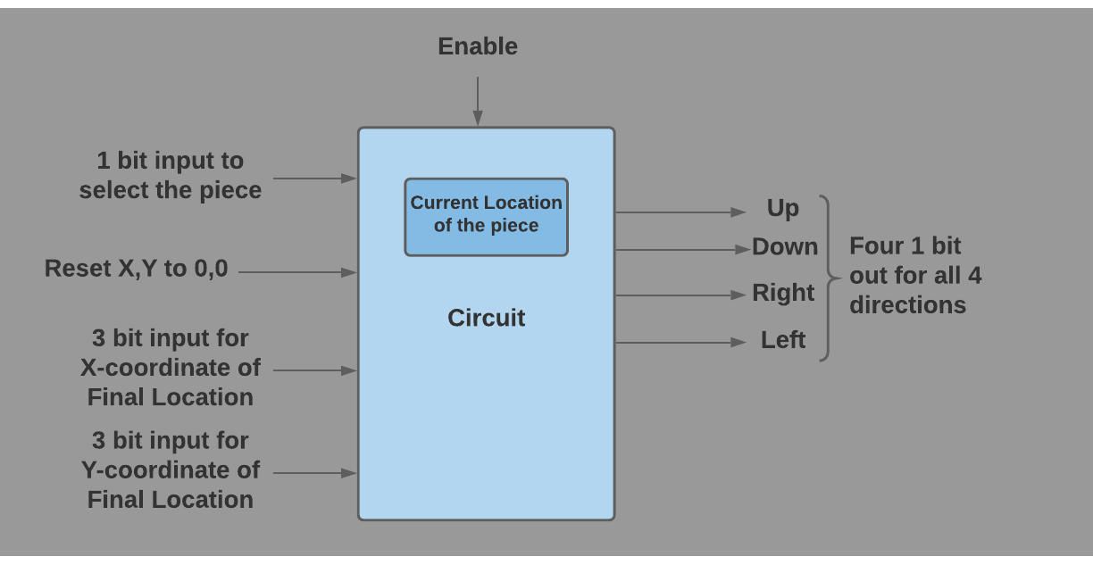](https://lucid.app/documents/edit/a1707f15-e5f3-4b80-a854-2b041d4f56ea/0?callback=close&name=docs&callback_type=back&v=861&s=612)

## 

## Inputs -

* Input to **select the piece** to be moved
  + To move **queen** give the input 0
  + To move **rook** give the input 1
* **X-coordinate** input
  + 3 bit input of the x-coordinate of final location in binary form.
* **Y-coordinate** input
  + 3 bit input of the y-coordinate of final location in binary form
* Circuit **Enable**
  + Circuit works when enable is 1
* A physical button used as **Reset**
  + When reset is 1, the location of the piece would be initialized to 0,0

## 

## Output -

* Four 1 bit outputs which would be used as input for actuator, which could convert it to timing diagrams for inputs of servo motors. The states are coded as follows
  + When Up is 1 ,the piece moves up ,else does not change in that direction.
  + When Down is 1 ,the piece moves Down ,else does not change in that direction.
  + When Left is 1 ,the piece moves Left ,else does not change in that direction.
  + When Right is 1 ,the piece moves Right ,else does not change in that direction.
* The value store in the JK Flip Flop or the Register can also be logged to check the movement and the current location of the piece.

**State Table**

LSB output of Priority encoder = v

MSB output of Priority encoder = u

Xs = Stored value of X coordinate

Xi = Input of X coordinate

Ys = Stored value of Y coordinate

Yi = Input of Y coordinate

For Rook-

Piece = 1

For uv= 00 , Xs > Xi,

For uv= 01 , Xs= Xi,

For uv= 10 , Xs<Xi,

For uv= 11 , Ys != Yi

For Queen-

Piece = 0

For uv= 00 , Xs > Xi,

For uv= 01 , Xs= Xi,

For uv= 10 , Xs<Xi,

For uv= 11 , Ys != Yi and Xs != Xi and |Xs-Xi| != |Ys- Y1|

|  |  |  |  |  |
| --- | --- | --- | --- | --- |
| **X coordinate** | | | | |
| **Present State** | **Next State** | | | |
|  | uv=00 | uv=01 | uv=10 | uv=11 |
| S0 | x | S0 | S1 | S0 |
| S1 | S0 | S1 | S2 | S1 |
| S2 | S1 | S2 | S3 | S2 |
| S3 | S2 | S3 | S4 | S3 |
| S4 | S3 | S4 | S5 | S4 |
| S5 | S4 | S5 | S6 | S5 |
| S6 | S5 | S6 | S7 | S6 |
| S7 | S6 | S7 | x | S7 |

Similar State Table of Y coordinate can be obtained by replacing Xs with Ys , Ys with Xs , Xi with Yi and Yi with Xi.

**State Diagram**

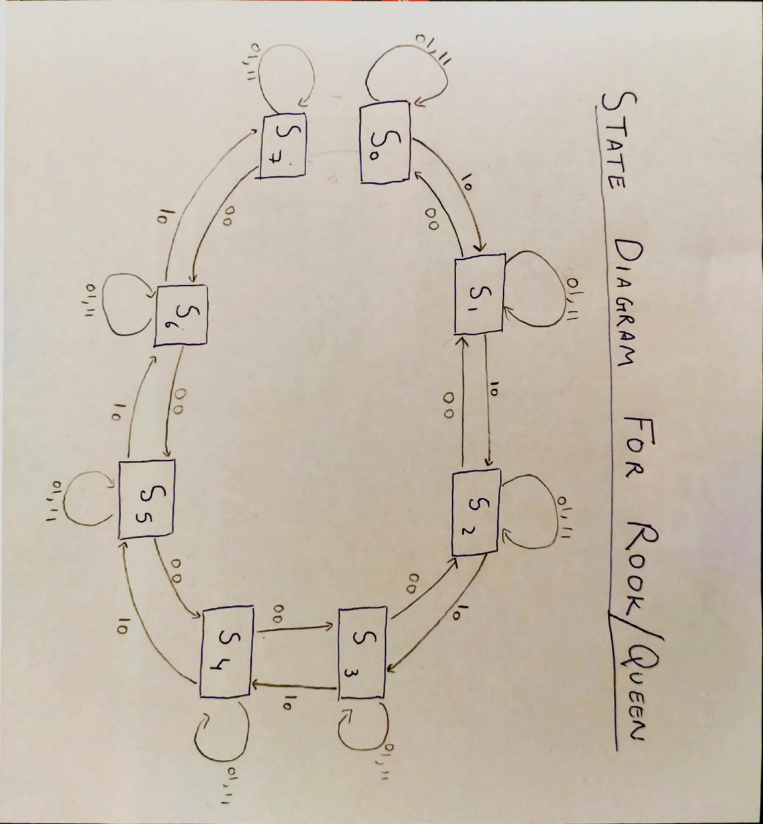

**Sample input/output Combination**

## Sample Output for Queen

The following Logging Table shows the move of Queen from (3,4) to (0,7). It also shows how servo motors would carry out this move (first left then up for 3 times).

Piece = 0 (Queen), x2 x1 x0 are inputs of X coordinate and y2 y1 y0 are inputs of Y coordinate , X and Y are the Binary representation of the Current location of queen starting from (3,4) to (0,7)

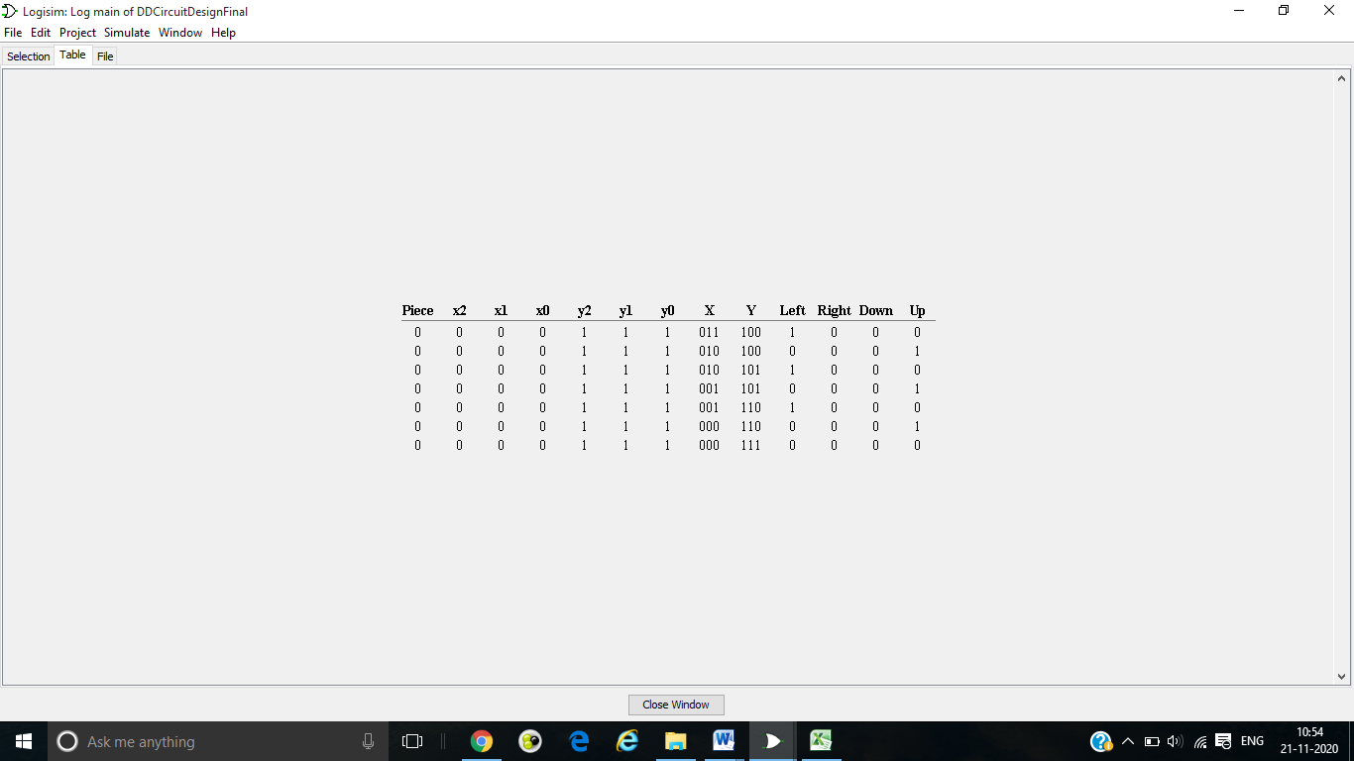

## Sample Output for Rook

The following Logging Table shows the move of Rook from (2,4) to (6,4). It also shows how servo motors would carry out this move (right 4 times).

Piece = 1 (Rook) , x2 x1 x0 are inputs of X coordinate and y2 y1 y0 are inputs of Y coordinate, X and Y are the Binary representation of the Current location of rook starting from (2,4) to (6,4)

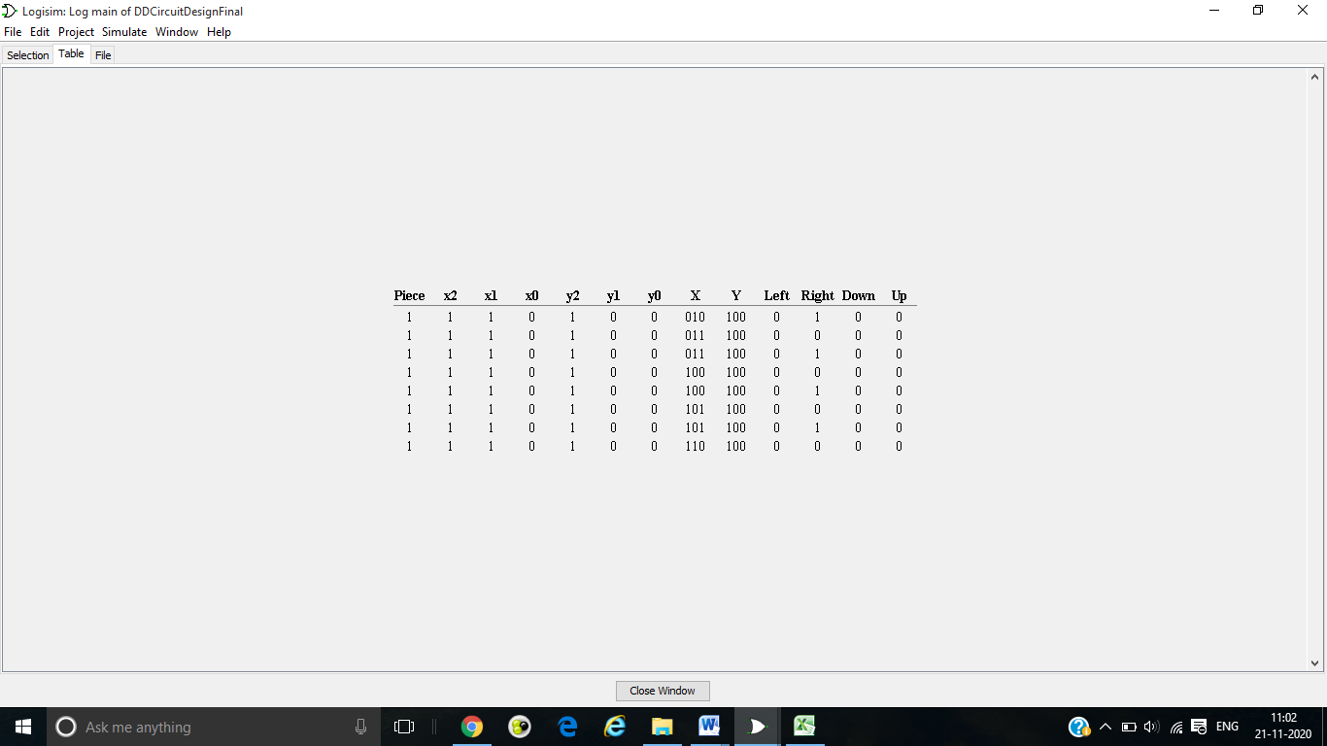**Circuit Diagram**

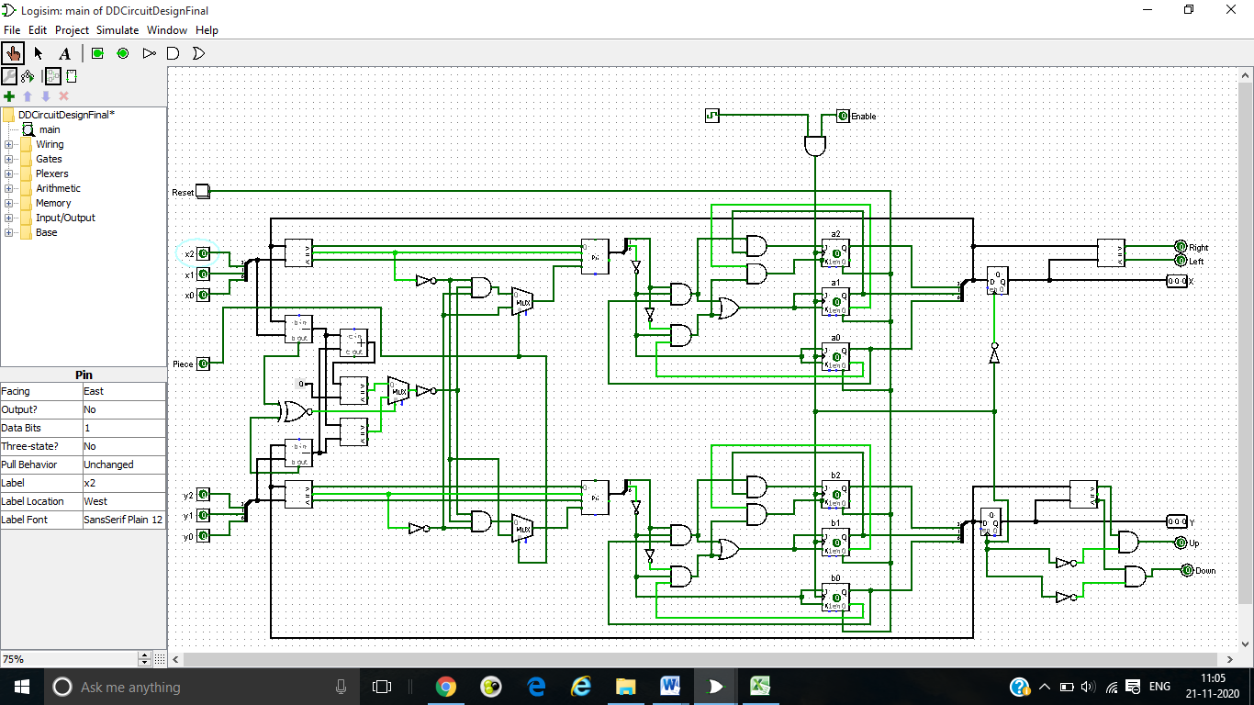

# **Further Development**

1. The inputs for the coordinates can be converted to Decimal inputs from binary to improve user-experience , by using an encoder.
2. Checking the validity of the move can be improved , checking if the path is empty or not can be implemented.
3. The circuit can be expanded to include all the pieces and the pieces can be coded as follows

4 bits representation with MSB representing the color(black or white) of the piece

* + - Pawn 0001
    - Knight 0010
    - Rook 0011
    - Bishop 0100
    - Queen 0101
    - King 0110